Name Mustafa
Sp23-bse-67
SSD for login MODULE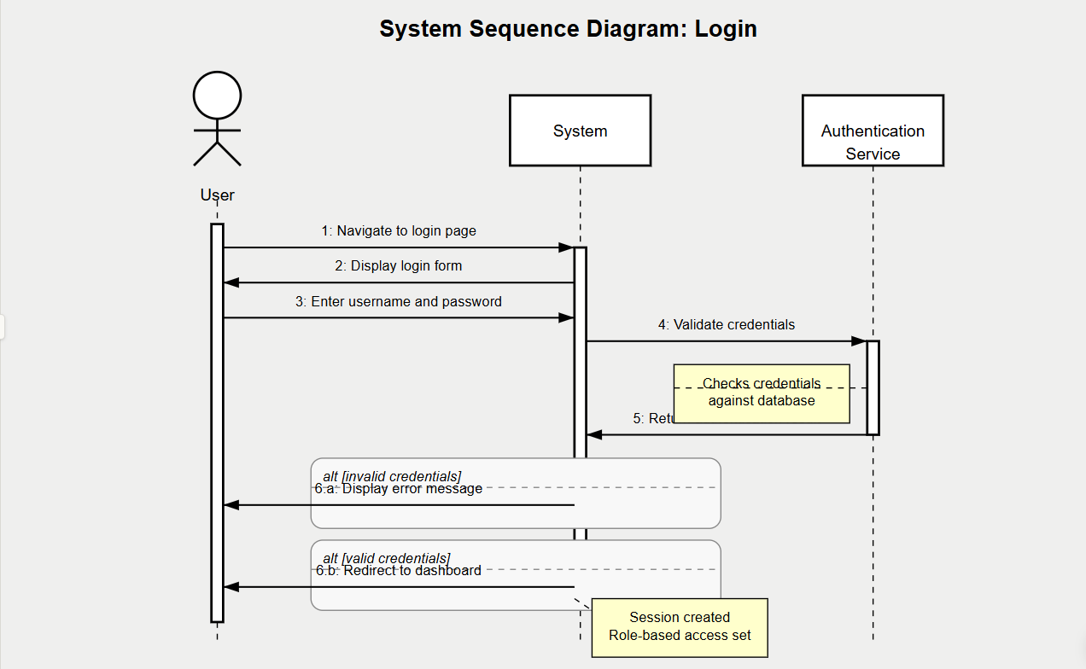

The SSD illustrates the sequence of interactions between:
- The User
- The System (Student Feedback System)
- The Authentication Service
Key interactions shown in the diagram:
- User navigates to the login page
- System displays the login form
- User enters username and password
- System validates credentials with Authentication Service
- Authentication Service returns result
- Alternative paths:
  - If invalid: System displays error message
  - If valid: System redirects to dashboard
The diagram includes activation bars showing when each component is active and notes explaining key operations like credential verification and session creation.

